Sequence Diagrams

Login/Signup

File Complaint

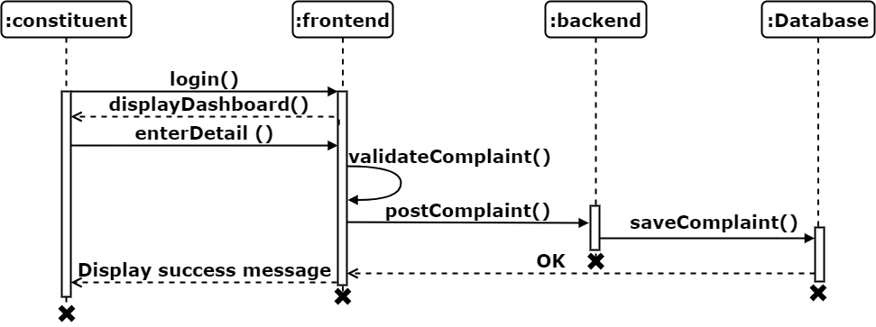

Resolve Complaint

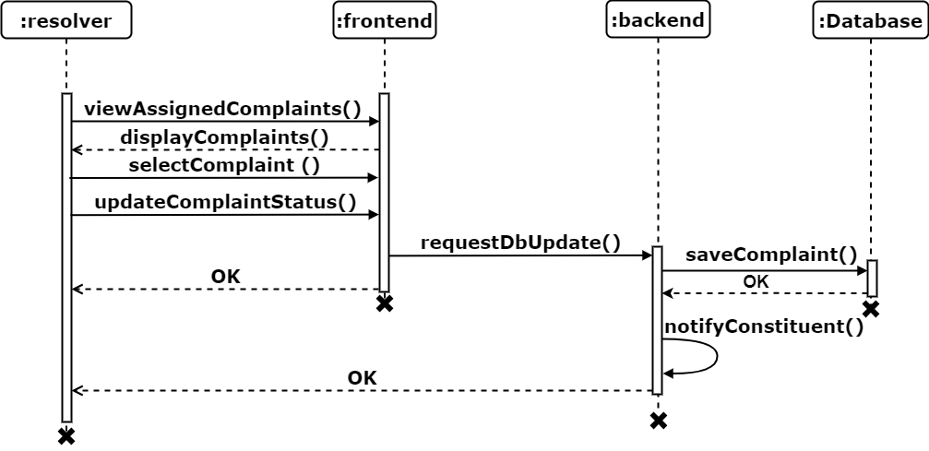

Submit Feedback

Post Event

